Chianna Alexander

Kyle Thompson

Shamili Sampath

10/11/2017

ECE 571 F17 Final Project Proposal - Drone controller

Our proposal is to build a controller that will provide forward, reverse, left and right control of a quad-copter(a.k.a. Drone). The quadcopter, as the name implies, has four motors that provides lift and directional movement. Varying the speed of a motor varies the lift at the motor location. If a motor is running slower than the other three, the craft will tilt (pitch) the aircraft causing forward motion. Make the same motor run faster, relative to the other three, the craft will fly in the opposite direction. Many drones are piloted using a radio link that has information modulated onto a RF signal. The motor speed is proportional to stick movement on the transmitter. On the proposed Drone controller, the transmitter will send directional commands and the controller figures out how to implement the motion. The receiver in the drone demodulates the signal into a group of bits (need to define now many) that are the commands for motion.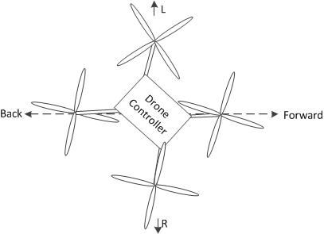

The Drone controller project starts at the interface of the command bits. The command controller block decodes the command bits and determines the correct rpm for each motor and generates a RPM set binary number that serves as the RPM set for the motor controller.

To achieve a stable aircraft the motor rpms must be constant and must be matched to the other motors. Electric motors with attached propellers have many variables that can cause the rpms to vary. A servo controller brings stability to a motor control system by using the feedback from a tachometer, an 8 bit binary value. The feedback is algebraically summed with the set point to create an error value that is operated on by a transfer function (tbd) in the Servo Controller block and produces a pulse width modulated (PWM) signal to control each motor.

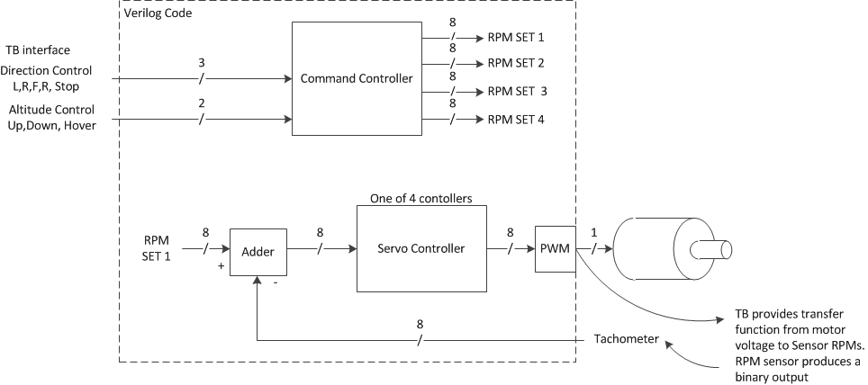

The test bench will require testing at all module levels, but specifically at the top level, there will need to be a variety of tests within the test bench to ensure correct functionality. First, the translation from the encoded direction needs to be tested for correct PWM duty cycles assuming without introducing simulated real-world speed errors. This will test that the set points are generated correctly. Next, each of these directions will need to be tested with inducing motor speed errors to show that the logic can correct for real-world errors. All of these combinations will also need to be tested with the up/down/hover input combinations. There are also likely to be different error input patterns. For instance, only one motor showing speed errors versus all four having errors are two distinct conditions which should be tested.